**58. Relational and Logical Operators.**

1. **Relational Operators**: These operators are used to compare the values. They return the boolean values.

<, <=, >, >=, ==, !=

2. **Logical Operators**: To combine two or more conditional statements we use Logical Operators.

**&&(And):** If all statements are true it returns true as a value otherwise it returns false as a value.

**||(Or):** If any statement is true it returns true as a value otherwise it returns false as a value.

**!(Negation):** It returns the opposite value.

**59. Conditional Statements.**

1. **Conditional Statements:** Conditional statements are the statements that execute as per the value of the conditions.

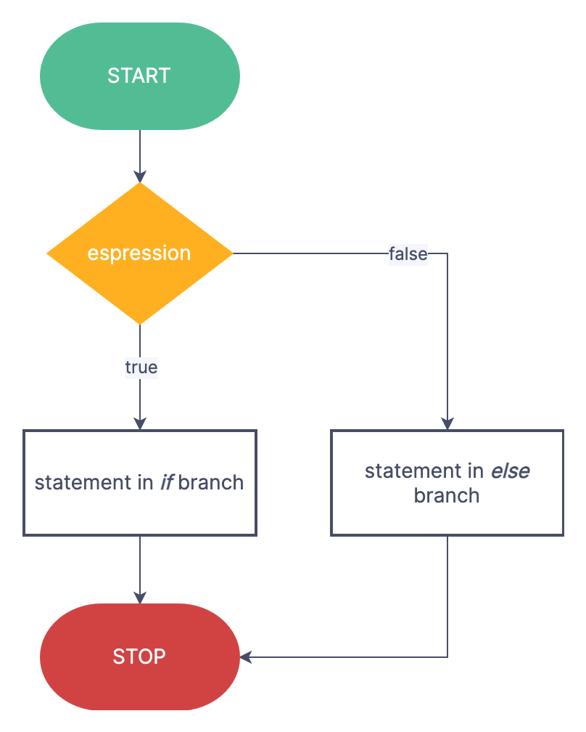

2. **If-else(Condition):** Executes statements as per the value of condition.

3. **Nesting(Condition):** Conditional statements inside conditional statements.

For example: **else-if** ladder, etc.

**...**

**Switch.**

1. Switch cases use all values except float values. It is used for menu driven program.

2. It is fast and efficient compared to If-Else.

3. **Break** keyword is used to stop the execution of Switch.

**…**

**Loops.**

1. **While Loop Syntax:**

**while(condition)**

**{**

**//Statements**

**}**

2. **Do-while Loop Syntax:**

**do{**

**//Statements**

**}(condition)**

3. **For Loop Syntax:**

**for(initialization; condition; updation/counter)**

**{**

**//Syntax**

**}**